# **Scatter Plot**

Simple scatter plot

Bubble chart 🡪 extended variant of scatter plot.

Uses

With ordering [Not alphabetical, but ordered with total arrest]

Without ordering (Here it is alphabetically ordered)

What is the 4th highest, 7th lowest ?

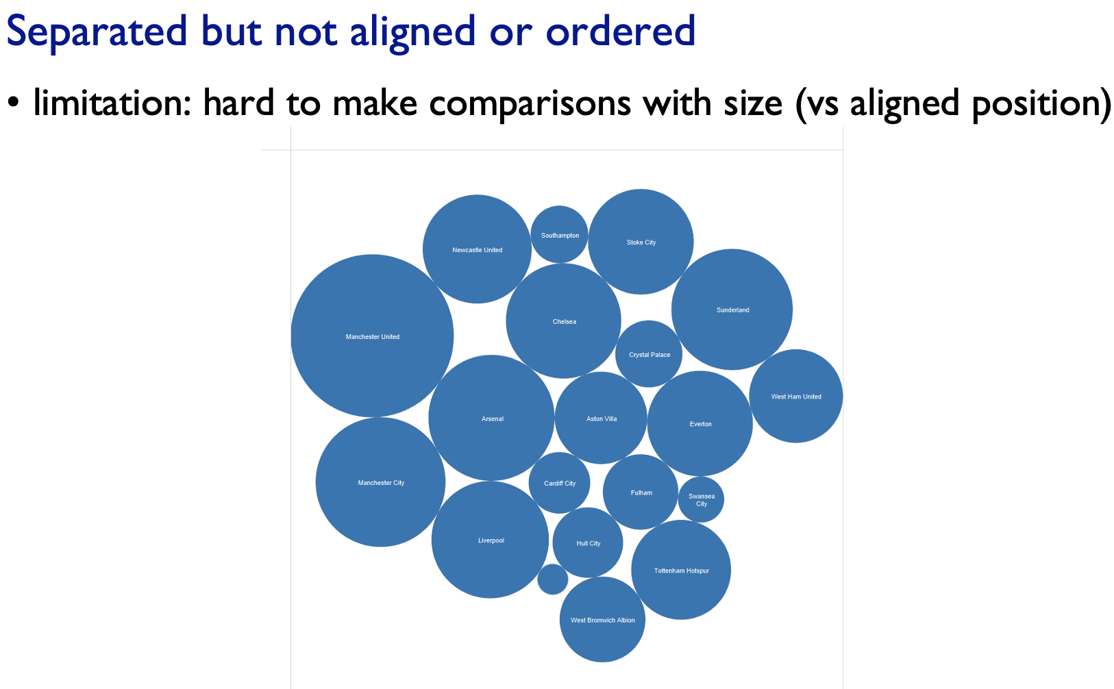Yet we can find the biggest and smallest, but it is much hard to make the find grain comparisons of size with these circles than it was those aligned length (ordered bar-chart).

# **Bar Chart**

# **Stacked Bar Chart**

The second categorical attribute(stacked key attribute or glyphs) is used to divide up again the spatial regions.  
There can be many key attributes in the bar chart,  
But we cannot visualize more than 10 segments in the stack.

# **Stream Graph**

This is a box-office data, where the profit will be more initially and flattens out, and then increases at the end (100th day like that)